Assignment

Docker and kubernetes

|  |  |
| --- | --- |
| Assignment Date | 15 November 2022 |
| Student Name | R.janani |
| Student Roll Number | 9208191040016 |
| Maximum Marks | 2 Marks |

Question-1:

1)Pull an image from docker hub and run it in docker playground.

Docker Playground:

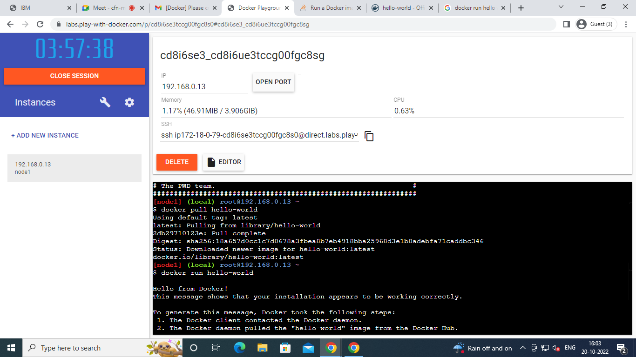

**Question 2:**

Create a docker file for the jobportal application and deploy it in Docker desktop application.

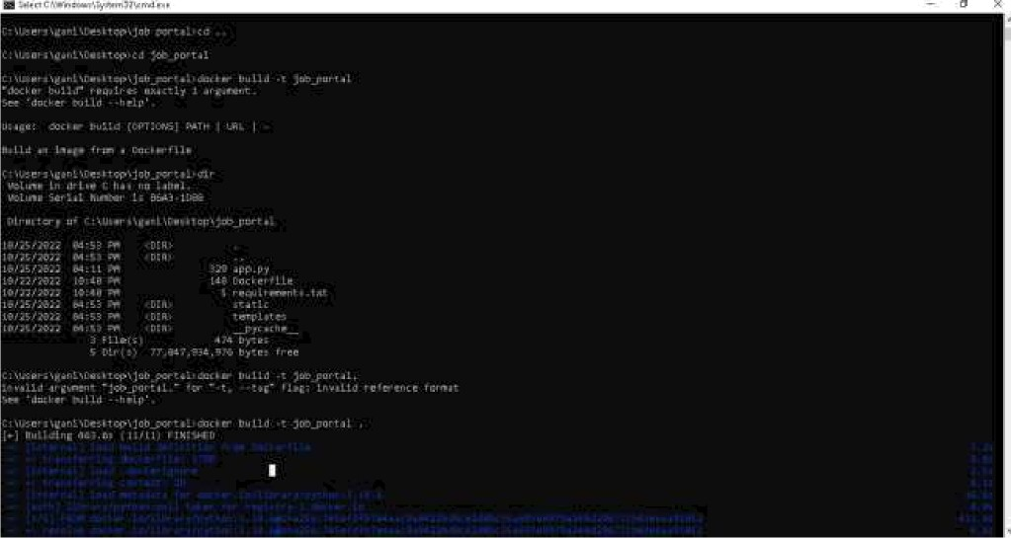

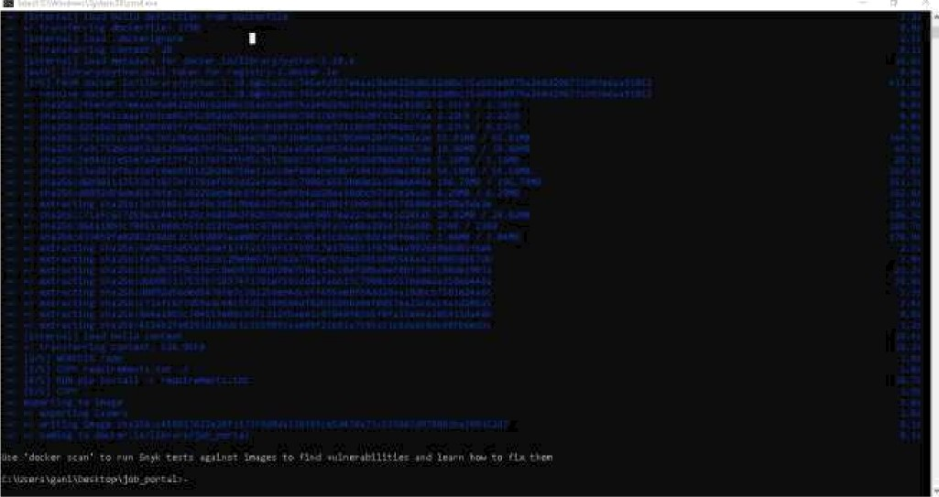

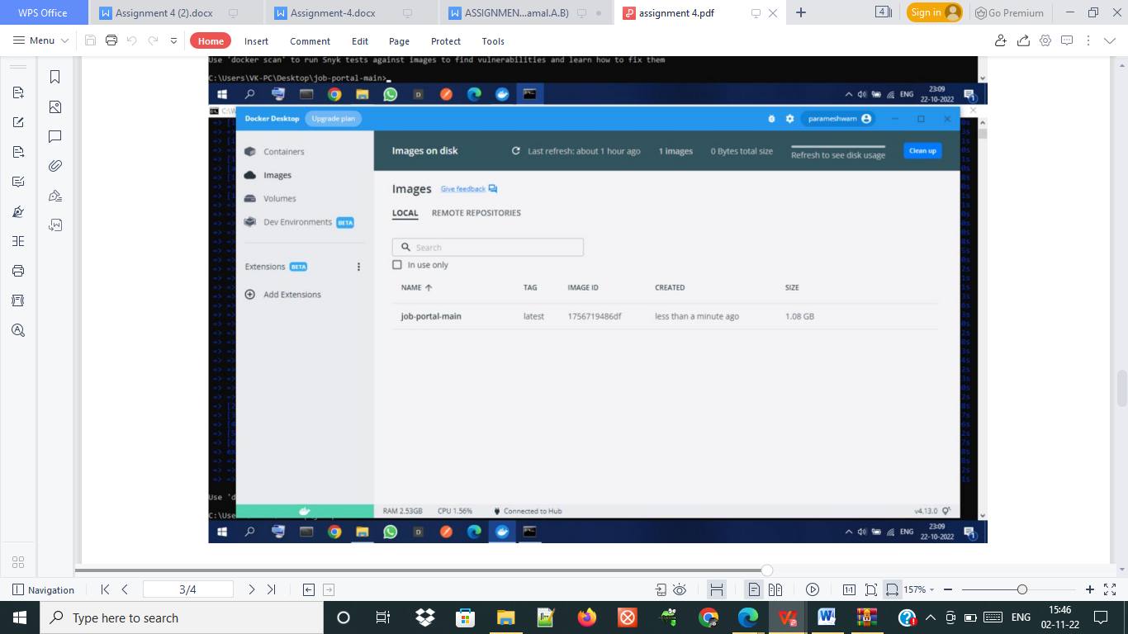

**Question 3:**

|  |
| --- |
|  |
|  |  |

|  |
| --- |
|  |
|  |  |

Create a IBM container registry and deploy helloworld app or jobportalapp.

|  |
| --- |
|  |
|  | IBMContainerRegistryOutput_2.jpeg |

|  |
| --- |
|  |
|  |  |

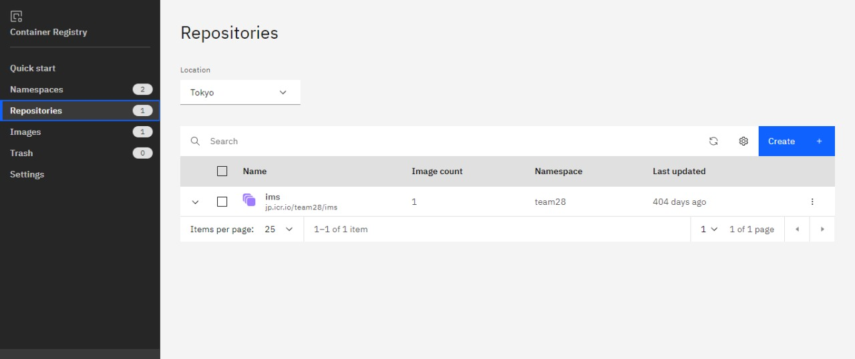

|  |
| --- |
|  |
|  |  |

Question 4:

Create a Kubernetes cluster in IBM cloud and deploy helloworld image or jobportal image and also expose the same app to run in nodeport.



  
  
  
    

  
  
  
    